# **MATILLION - COST MONITORING DASHBOARD**

Monitoring Matillion credit consumption through Snowsight dashboards provides *real-time insights, cost transparency, and customizable metrics*. With Snowsight, you can track credit usage, analyze trends, and drill down into details. The dashboards offer powerful data visualization, facilitating effective communication of credit consumption patterns. You can collaborate with stakeholders and share the dashboards for a shared understanding of costs.

Snowsight also supports alerting and notifications to promptly identify significant changes in credit usage. By leveraging Snowsight's capabilities, you can optimize resource allocation, make informed decisions, and control costs. The real-time visibility helps you understand the financial impact of your Matillion usage, plan budgets, and forecast future capacity needs.

Below are some KPIs which help to get necessary information for efficient cost management and resource optimization.

## Overall Credits Consumed :

select sum(credits) from MATILLIO_LOG.CREDIT_USAGE.MATILLION_CREDITS;



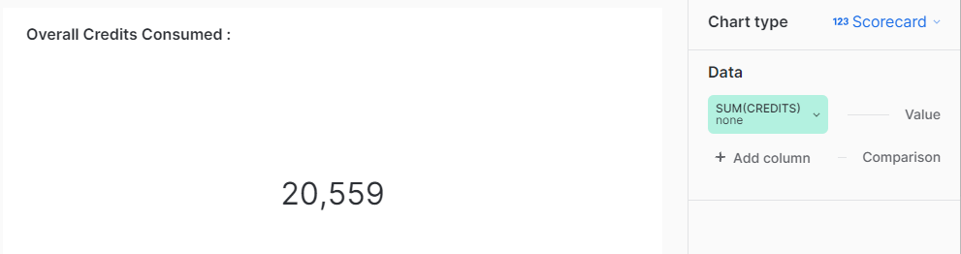

## Credits Consumed this month :

select sum(credits) from MATILLIO_LOG.CREDIT_USAGE.MATILLION_CREDITS where

monthname(used_at)=monthname(current_date) ;



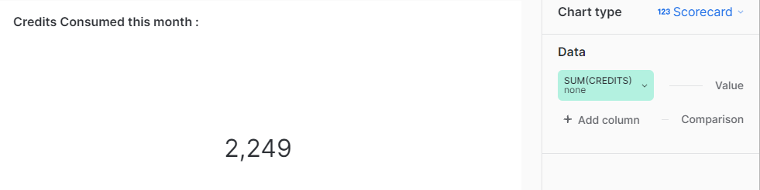

## Current Pricing Plan :

select plan as "Current Plan" from MATILLIO_LOG.CREDIT_USAGE.MATILLION_CREDITS

order by used_at desc limit 1;



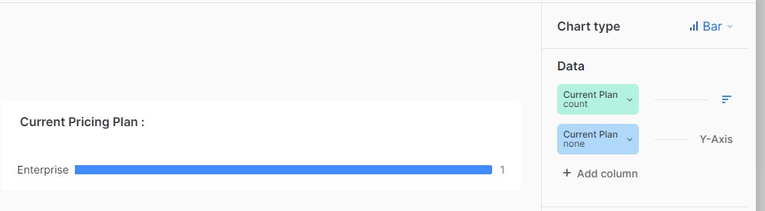

## Current Subscription Tier :

select SUBSCRIPTION as "Current Scubsciption Tier" from MATILLIO_LOG.CREDIT_USAGE.MATILLION_CREDITS

order by used_at desc limit 1;



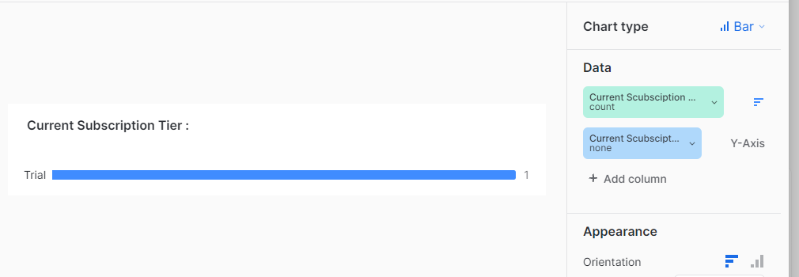

## Monthwise credits consumed :

select sum(credits) as total_credits, to_date(used_At) as mon_part

from MATILLIO_LOG.CREDIT_USAGE.MATILLION_CREDITS group by mon_part;



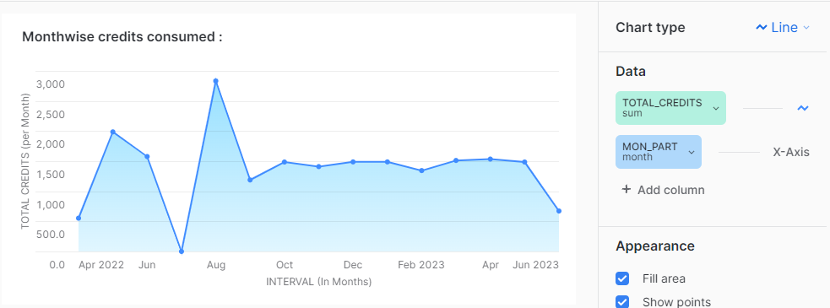

## Subscription History :

select distinct(plan) as current_plan, to_varchar(min(used_at),'dd mon yyyy') as Subscription_date from MATILLIO_LOG.CREDIT_USAGE.MATILLION_CREDITS

group by current_plan order by Subscription_date desc;

 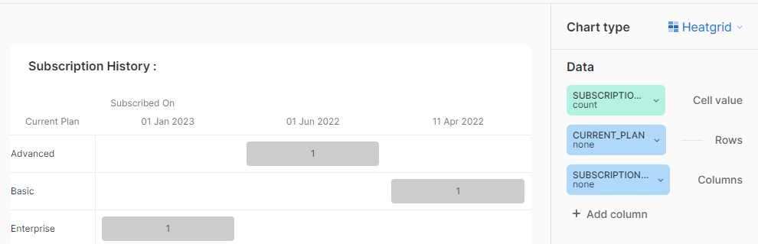

## Credits used for any month:

select replace(split(to_varchar(used_At,'mon yyyy ,dd'),' ,')[0],'"','') month_interval

from MATILLIO_LOG.CREDIT_USAGE.MATILLION_CREDITS

where date_part('year',used_at)= :yr and date_part('month',used_at)= :mon

group by month_interval ;



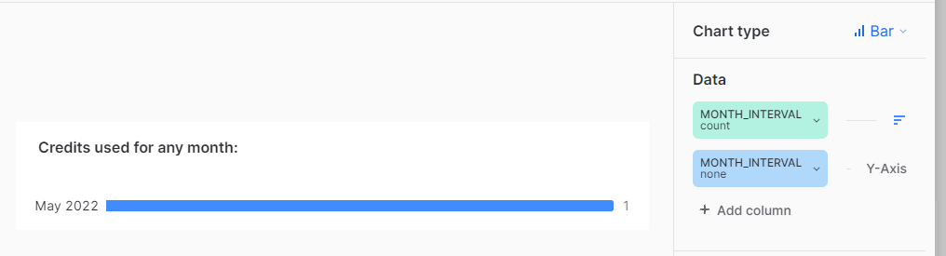

## Total credits consumed :

select sum(credits) as total_credits, 'Total credits' as header,

replace(split(to_varchar(used_At,'mon yyyy ,dd'),' ,')[0],'"','') month_interval

from MATILLIO_LOG.CREDIT_USAGE.MATILLION_CREDITS

where date_part('year',used_at)= :yr and date_part('month',used_at)= :mon

group by month_interval ;



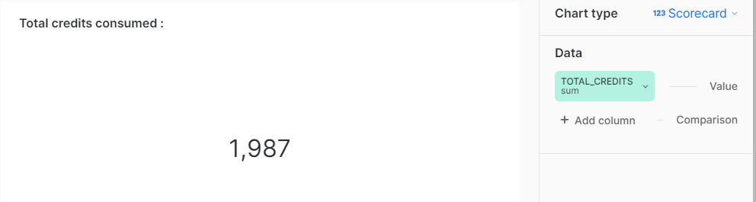

## Pricing plan :

select distinct(plan)

from MATILLIO_LOG.CREDIT_USAGE.MATILLION_CREDITS

where date_part('year',used_at)= :yr and date_part('month',used_at)= :mon



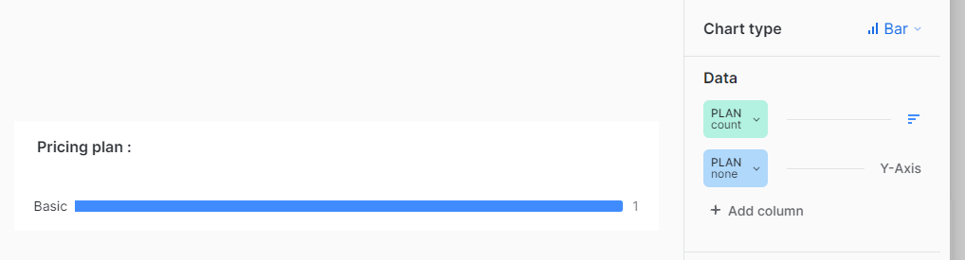

## Billed Amount :

select sum(credits) as total_credits,'Cost' as header,

case when subscription='Trial' or Plan='Free' then 0

when subscription='Pay-as-you-go' and Plan='Basic' then total_credits*2.00

when subscription='Pay-as-you-go' and Plan='Advanced' then total_credits*2.50

when subscription='Pay-as-you-go' and Plan='Enterprise' then total_credits*2.70

end as credits_to_cost

from MATILLIO_LOG.CREDIT_USAGE.MATILLION_CREDITS where

month(used_at)=:mon and year(used_at)=:yr group by subscription, plan ;



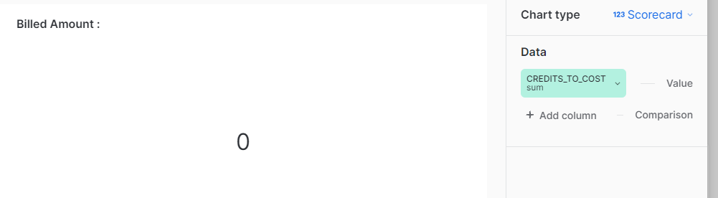

## Credits Consumed on the selected month:

select credits, to_Date(used_at) from MATILLIO_LOG.CREDIT_USAGE.MATILLION_CREDITS

where date_part('year',used_at)=:yr and date_part('month',used_at)=:mon;



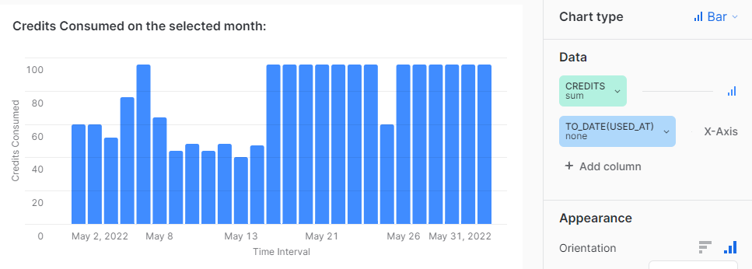

## Filters

1. = Month

Filter Keyword = :mon

Other configurations:

**Filter Name**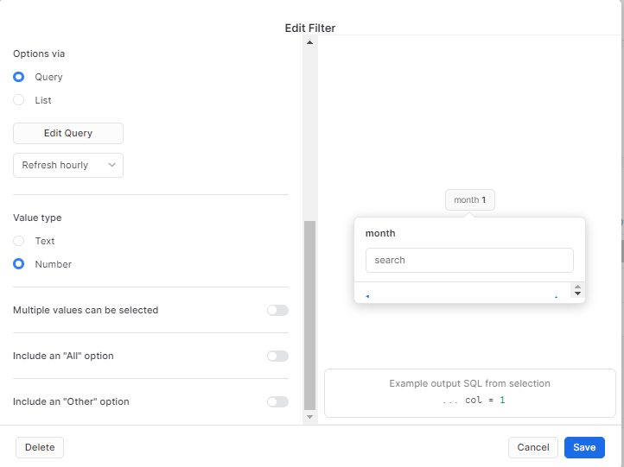

**Query**:

select distinct date_part('month', used_at)as month from MATILLIO_LOG.CREDIT_USAGE.MATILLION_CREDITS

order by month;



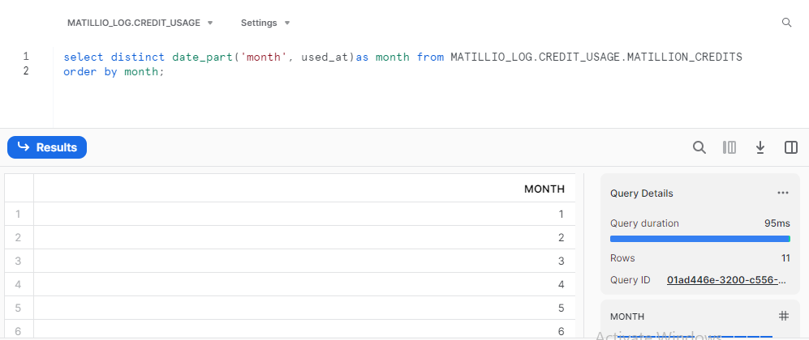

1. **Filter name** = year

Filter keyword = :yr

Other configurations =

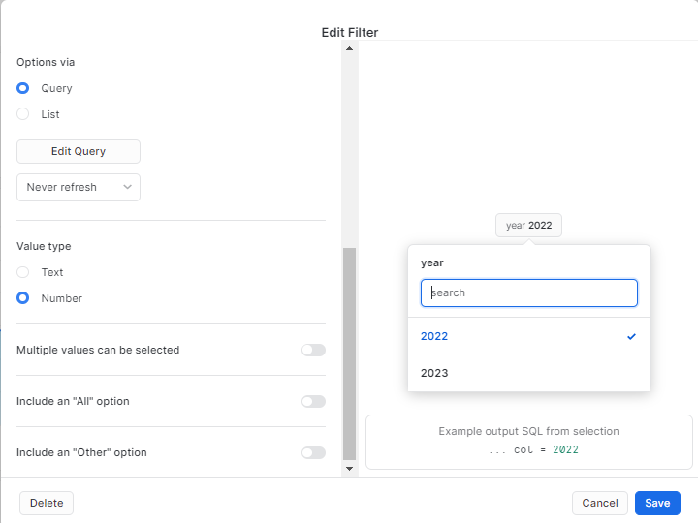

**Query:**

select distinct date_part('year',used_at) from MATILLIO_LOG.CREDIT_USAGE.MATILLION_CREDITS;



